**Building Resilience in an Uncertain World using AI to automate Defect Detection**

Risk management is evolving from being a reactive function to becoming a strategic enabler. With ever-increasing frequency and complexity of global disruptions—such as geopolitical instability, supply chain challenges, and climate change—have made building organisational resilience a top priority. A shift from short-term risk mitigation to long-term resilience planning is vital.

As the complexity of the risk landscape grows, so does the challenge of managing these interconnected dependencies, where a failure can have multiple unforeseen ripples.

How can Space East members respond? By improving your sensor and sense-making capabilities (e.g. by using AI and Big Data) to attenuate (filter), Space East members can better understand what is ***known*** and ***controllable***.

**Generative AI to share your project’s story in a data driven way**

Predicting asset failures predictive maintenance by combining asset monitoring data with Machine Learning (ML) & Digital Twins. Machine Learning (ML) powered automated data analysis for asset inspection to enable predictive maintenance and mitigation actions at the point of impact.

Figure - Use of Machine Learning (ML) powered automated data analysis for asset inspection

## **Case Study: Automate Defect Detection Using Drones and OCI Vision for Digital Twins**

OCI Vision is an AI service for performing deep learning-based image analysis at scale, using Prebuilt, and Custom Models.

Use of an advanced AI service in image processing on a large scale with the aid of deep learning, which provides pre-built models for image and text recognition in an automated way.

OCI Vision plays a pivotal role in automating defect detection in construction scenarios.

* Detecting issues across assets can be time consuming and labour intensive, but it can be automated with AI. Oracle’s AI vision can automate defect detection for digital twins, leveraging Oracle Cloud Infrastructure (OCI) Vision. This type of solution can detect rust asset information using images collected by drones.
* Raw data is gathered by drones inspecting specific areas of a construction project, and the images are uploaded to OCI Object Storage. An event trigger then initiates the OCI Vision service, which employs custom models to detect anomalies within the collected images.

OCI Vision provides information about detected labels, objects, text, and faces, and it provides the time at which they’re detected. OCI Vision can classify images into thousands of categories to simplify common digital asset management scenarios or identify items that need attention.

For industry-specific use cases, Space East members can automatically train custom vision models with their own data.

**You can use it for the following common use cases:**

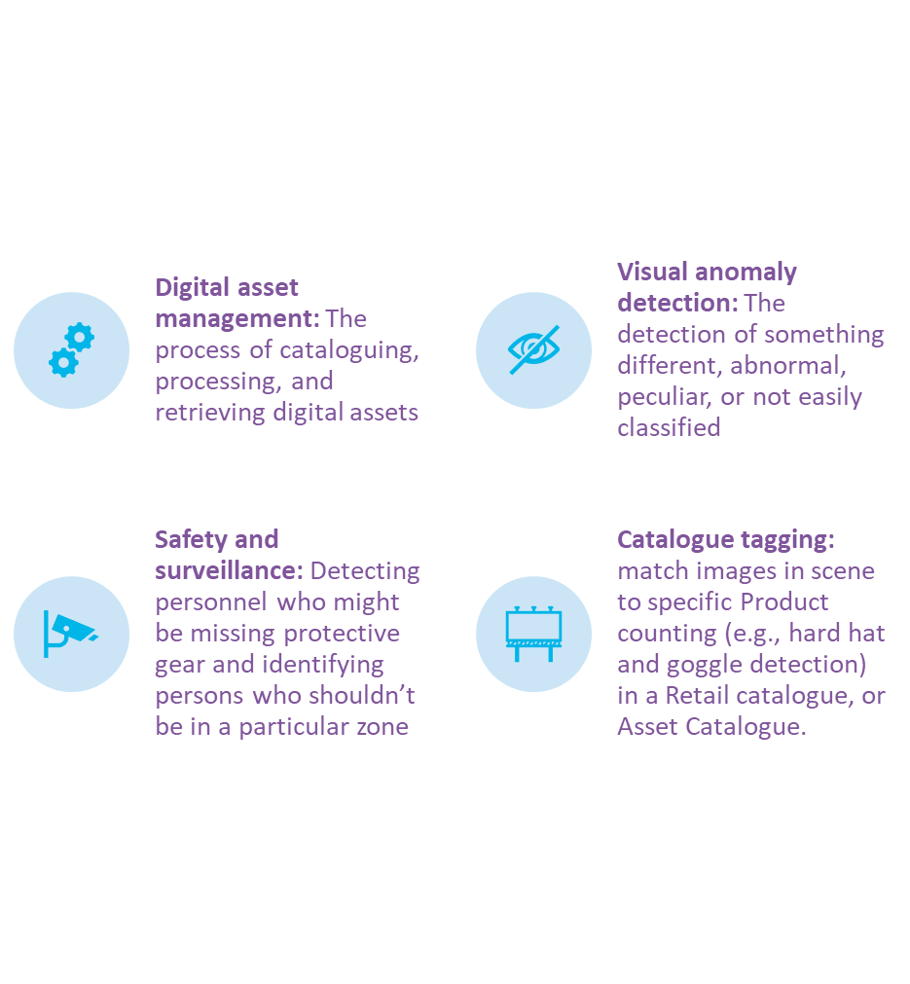

Figure - OCI Vision can classify images into thousands of categories to simplify common digital asset management scenarios or identify items that need attention, such as overgrowth near a power line.

OCI Vision provides information about detected labels, objects, text, and faces, and it provides the time at which they’re detected.

With a timeline bar, you can navigate to the exact timestamp in the video to find a particular label or object for the following scenarios:

**Image analysis built for enterprise scenarios**

Figure - With a timeline bar, we can directly look for a label or object and navigate to the exact time stamp in the video where a particular label or object is found.

**AI Generative Reporting to help SPACE EAST**

**Let's talk real change. How we can help.**

These models can be used to detect visual anomalies in manufacturing, organize digital media assets, and tag items in images to count products or shipments.

**How-to-Start**

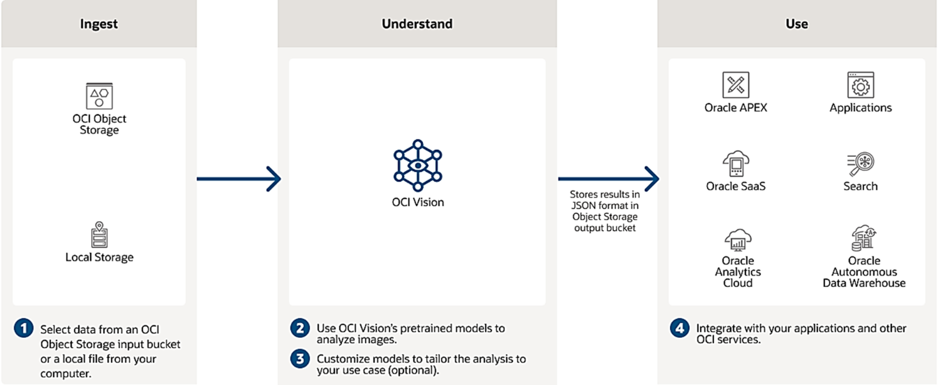

MSET model generates an accurate estimate, during the on-line monitoring stage, of what each signal ​“should be” based on the latest set of sensor readings and the previously learned correlations among them.

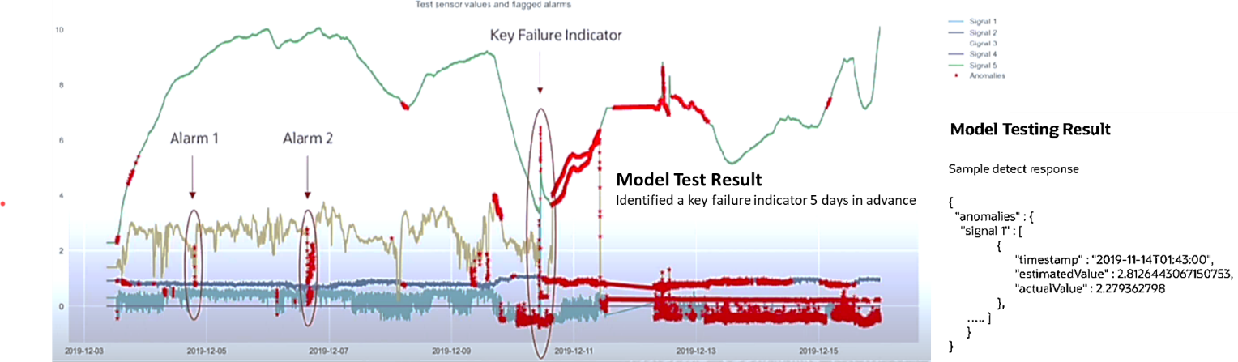

Figure - Leverage the power of Multivariate State Estimation Technique (MSET) to identify anomalies

The results return an array of anomalies grouped by timestamp. Each timestamp could have anomalies generated by single or multiple signals. Anomaly generated by one signal contains a tuple of signal name, actual value, estimate value, and an anomaly that indicates the significance of anomaly.

In the graph, horizontal axis represents the timestamp, and the vertical axis represents sensor values.

In each subgraph, orange line indicates the actual input value of a signal, purple line indicates the predicted value by the machine learning model, and red line indicates anomaly being detected at that timestamp.

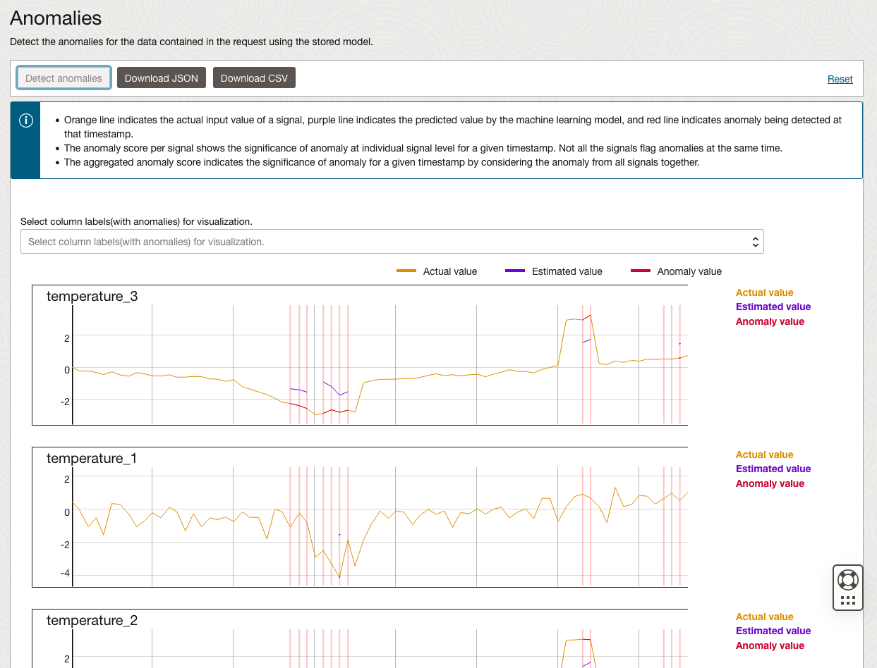

Figure - MSET models detect anomalies to determine, at the earliest possible time, of whether the process is behaving as expected or anomalously.

**About** **DADA Enterprises**

DADA’s ISO9001 and Six Sigma certified [consultancy service](https://www.big-dada.co.uk/packages/?CCS) has been repeatedly recognised by Consultancy.uk. DADA were shortlisted in the Britain’s Energy Coast Business Cluster (BECBC) 2023 Annual Awards, in their maiden year of membership, by National Nuclear Laboratory (NNL) in the "Innovation and Creativity" category. They showed how to create a [SMART Construction platform](https://tinyurl.com/4cs4xmxx) by turning project data into predictive intelligence to create a “risk radar”.